Software Requirement Specifications
Integrating Explainable AI for Transparent Educational Decision Support


Submitted by
Zohaib asif
F22BINFT1M01201

Submitted to
Dr. Mustafa Hameed

Department of Information Technology
Faculty of Computing
The Islamia University of Bahawalpur

Meeting Details
Sr No | Details | Date | Supervisor Signature
Summary
The Integrating Explainable AI for Transparent Educational Decision Support system is a web-based platform that enables educational institutions to make transparent, data-driven decisions on student performance. It predicts student outcomes using AI/ML models and provides human-understandable explanations through visualizations like graphs and heatmaps. The system offers role-based dashboards, report generation, and metrics tracking (attendance, grades, progress), while ensuring fast response, high reliability, security, and scalability. Built with Python, Flask, and MySQL, it integrates explainability tools like SHAP/LIME and supports future enhancements such as LMS integration, deep learning models, and a mobile interface.

Table of Contents
1. Introduction 4
1.1. Purpose 4
1.2. Scope 4
1.3. Product Perspective 4
1.4. User Characteristics 4
1.5. Similar apps and systems/Literature Review 4
1.6. Proposed Technologies 4
2. Requirements 5
2.1. Function Requirements 5
2.1.1. Sign Up 5
2.2. Non-Functional Requirements 5
3. Use Cases and Flow of Processes 6
3.1. Use Case 1 7
4. References 8

1. Introduction

1.1 Purpose
The purpose of this Software Requirements Specification (SRS) document is to define the functional and non-functional requirements for the system 'Integrating Explainable AI for Transparent Educational Decision Support'. The system aims to support educational institutions with transparent, data-driven decisions on student performance and academic support.

1.2 Scope
The system will provide data-driven recommendations and visual explanations for decisions such as student evaluations, performance analysis, and resource allocation. The Explainable AI (XAI) module will provide human-understandable explanations for predictions.

1.3 Definitions, Acronyms, and Abbreviations
AI – Artificial Intelligence
XAI – Explainable Artificial Intelligence
SRS – Software Requirements Specification
ML – Machine Learning

2. Overall Description

2.1 Product Perspective
Web-based application built with Python that connects to a database and uses AI models to predict and explain student outcomes.

2.2 Product Functions
- Predict student performance and risk of failure.
- Explain predictions with visualized feature importance.
- Generate reports for teachers and administrators.
- Role-based dashboards (Admin, Faculty, Student).

3. Specific Requirements

3.1 Functional Requirements
ID | Requirement Description
FR1 | Allow users to log in and access dashboards based on roles.
FR2 | Analyze student performance data using AI models.
FR3 | Generate explainable outputs (reasoning, graphs, heatmaps).
FR4 | Allow administrators to upload or update student data.
FR5 | Display key metrics like attendance, grades, and progress.
FR6 | Generate reports summarizing AI-based recommendations.

3.2 Non-Functional Requirements
Performance: Response time under 3 seconds for predictions.
Usability: Intuitive interface for all roles.
Reliability: 99% uptime.
Security: Data encryption and role-based access control.
Scalability: Handle increasing numbers of students and records.

4. System Design Description

4.1 Use Case Diagram
The Use Case diagram is shown below:
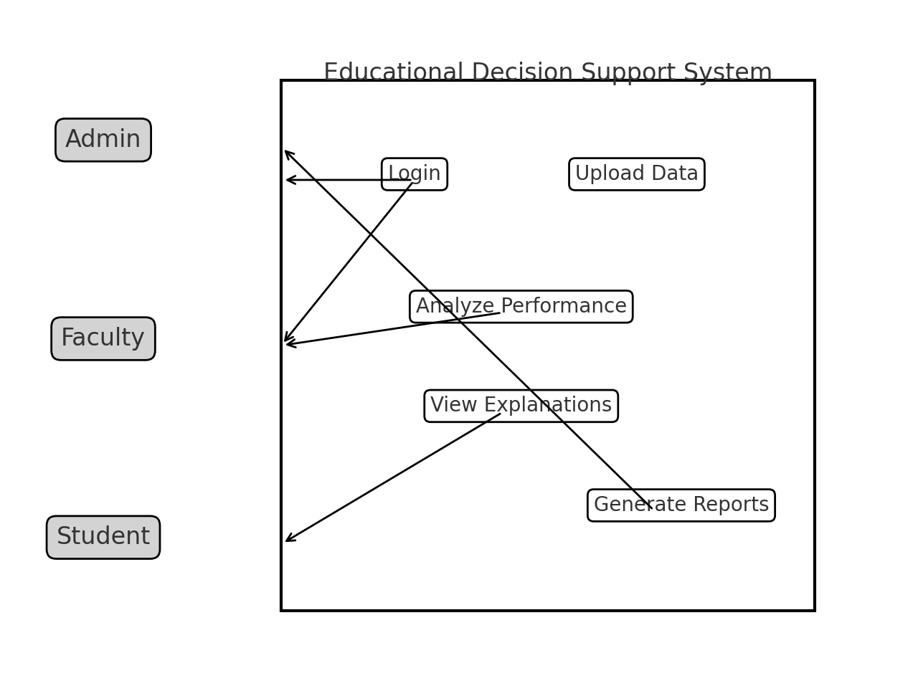

4.2 System Architecture (High-Level)
Frontend: Flask templates and HTML/CSS.
Backend: Python-based API and ML engine.
Explainability Layer: SHAP/LIME for feature explanations.
Database: MySQL or SQLite.
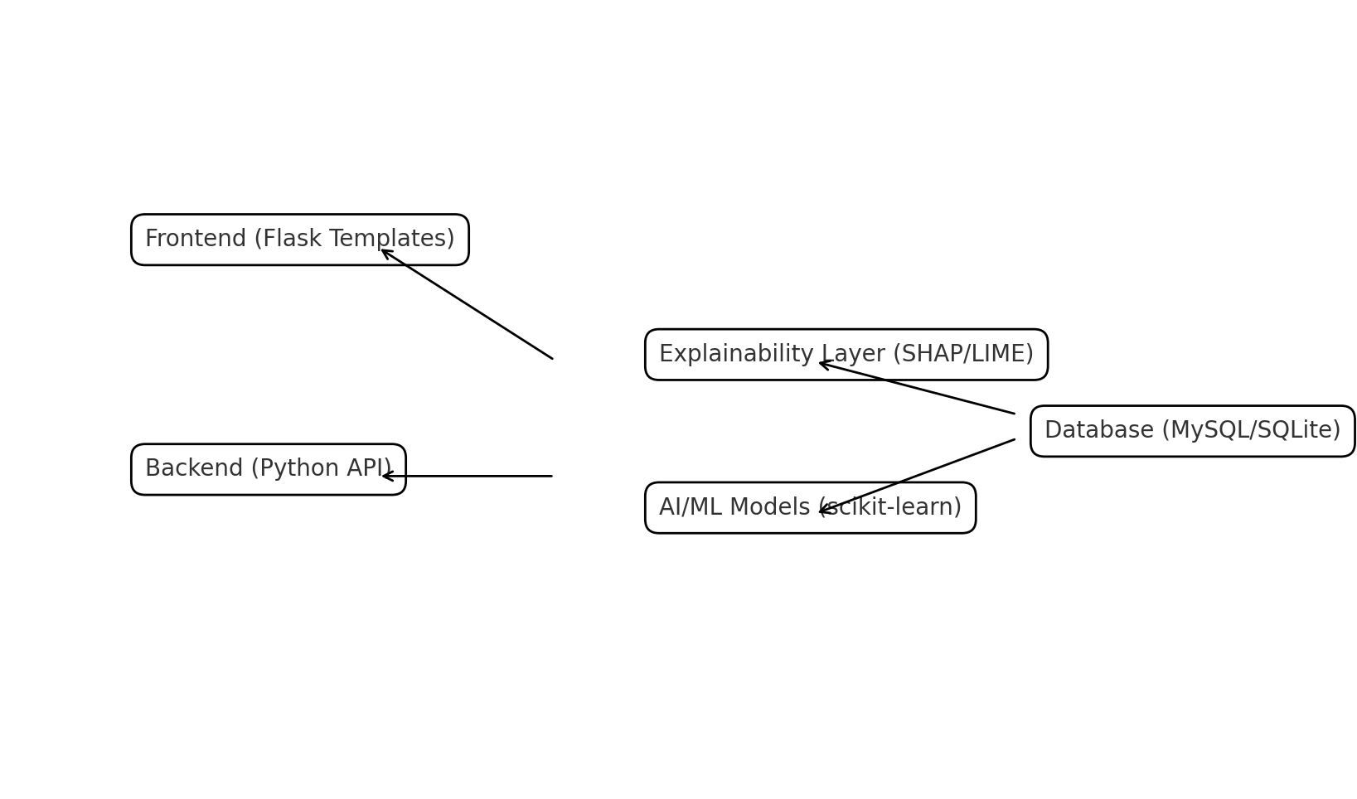

5. External Interface Requirements
User Interface: Dashboards with charts and tables.
Hardware: Server with minimum 8GB RAM recommended.
Software: Python 3.10+, Flask/Django, scikit-learn, pandas, SHAP, LIME.
Communication: HTTP/HTTPS, REST API.

6. Other Requirements
Regular backup, documentation of AI models, and compliance with data privacy policies.

7. Appendix
Future Enhancements: LMS integration, deep learning models, mobile app interface.

